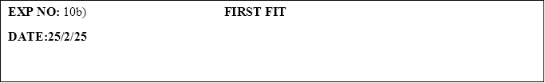

**PROGRAM:**

#include <stdio.h>

#define MAX 25

int main() {

    int frag[MAX], b[MAX], f[MAX], i, j, nb, nf, temp, highest = 0, bf[MAX], ff[MAX];

    printf("Enter the number of blocks: ");

    scanf("%d", &nb);

    printf("Enter the number of files: ");

    scanf("%d", &nf);

    printf("Enter the size of the blocks:\n");

    for(i = 0; i < nb; i++) {

        printf("Block %d: ", i + 1);

        scanf("%d", &b[i]);

    }

    printf("Enter the size of the files:\n");

    for(i = 0; i < nf; i++) {

        printf("File %d: ", i + 1);

        scanf("%d", &f[i]);

    }

    for(i = 0; i < nf; i++) {

        for(j = 0; j < nb; j++) {

            if(bf[j] != 1) {

                temp = b[j] - f[i];

                if(temp >= 0) {

                    ff[i] = j + 1;

                    bf[j] = 1;

                    frag[i] = temp;

                    break;

                }

            }

        }

    }

    printf("\nFile No.\tFile Size\tBlock No.\tBlock Size\tFragmentation\n");

    for(i = 0; i < nf; i++) {

        if(ff[i] != 0) {

            printf("%d\t\t%d\t\t%d\t\t%d\t\t%d\n", i + 1, f[i], ff[i], b[ff[i] - 1], frag[i]);

        } else {

            printf("%d\t\t%d\t\tNot Allocated\n", i + 1, f[i]);

        }

    }

    return 0;

}

**OUTPUT:**

Enter the number of blocks: 3

Enter the number of files: 2

Enter the size of the blocks:

Block 1: 3

Block 2: 4

Block 3: 2

Enter the size of the files:

File 1: 2

File 2: 4

File No. File Size Block No. Block Size Fragmentation

1 2 1 3 1

2 4 2 4 0